TITLE

Sounds of Futures Passed: Media Archaeology and Design Fiction as a NIME Methodology

ABSTRACT (100-200 words)

This paper provides a study of a cooperative learning workshop which invited composers, musicians, and designers to investigate electronic sound instruments from the history of the Royal College of Music in Stockholm (KMH) and EMS Elektronmusikstudion in Stockholm. The workshop applied Media Archaeology methods towards analyzing one particular instrument from the past, the Dataton System 3000, and Design Fiction methods towards imagining several speculative instruments of the future. Each section revealed very specific utopian ideas surrounding the design of sound instruments. Here, we lay out the intellectual, material, and social conditions of the workshop, along with a selection of the workshop's outcomes, and some reflections on their significance for the NIME community. By presenting this method-in-progress, our hope is to inspire dialog around the premise that the linked examination of historical electronic sound technology's affordances and ethics may bear rich fruit for contemporary instrument design practices.

AUTHOR KEYWORDS

Workshop, media archaeology, design fiction, organology

DESCRIPTION

A workshop study focusing on the investigation of the ethics and affordances of historical and speculative electronic sound instruments.

CCS CONCEPTS

Applied computing~Sound and music computing, Human-centered computing~Interaction design theory, concepts and paradigms

1. INTRODUCTION

Participatory workshops have consistently been valuable tools for studying the prototyping of New Interfaces for Musical Expression. Example workshops within the NIME community have ranged from exploring the cognitive and material relationships between gesture and sound (Tomas, Gorbach, Tellioglu, & Kaltenbrunner), or the use of hardware and software toolkits to involve children in instrument creation (Trappe), to rapidly prototype deliberately rough and unfinished sound interactions from everyday objects (Armitage & McPherson, Moriwaki & Brucker-Cohen), and the role of collaboration and teamwork in the design of novel instruments (Xambo, Saue, Jensenius, Stockart, & Brandtsegg). Several workshop studies focus on the the use of speculative design to fashion imaginary instruments and non-functioning models which can inform our design process by freeing us from the engineering constraints of reality (Andersen & Gibson; Andersen; Lepri & McPherson) or "solutionist" thinking (Blythe, Andersen, Clarke, & Wright) which seeks to apply the latest available technology to non-existent problems.

While countless NIME projects seek to repurpose or reinterpret classical acoustic instruments, fewer approaches seek an active dialog with the history of electronic sound. A survey of recent scholarship on the topic, however, finds exceptional research being done with the analysis and reconstruction of unique historical instruments (Richards), historical user studies of groundbreaking electronic instruments (Ojanen), and the reenactment of canonical musical performances with these reproductions (Teboul) which straddle the border between the worlds of conservation and musicology on the one side, and new artistic creation on the other. And previous NIME presentations have introduced the designs and interfaces of under-researched musical devices (Ojanen et al), drawn inspiration from neglected historical computer compositions (Savery et al), or re-examined historical experimental music concepts such as the "readymade" (Bussigel et al) as the starting points for contemporary works.

Our workshop took place within the context of ongoing research into historically-informed sound synthesis, focusing on several devices used by electronic composers in Sweden during the 1960's and 70's. Although an organology of these historic instruments was necessary, the authors felt that a taxonomy of their functions of sound causation alone would not be relevant. Far more relevant were concepts from the discipline of Science and Technology Studies (STS), which take into account what sort of affordances the instrument provides the user, the degree to which the instrument becomes an autonomous co-creator of a work, and the ends to which the instrument is directed, or its "ethics" (Tresch & Dolan), and map these aspects out in a heterarchical rather than hierarchical manner (Magnusson 1,2). In the case of sound synthesis technology from a half century ago, these ethics were often utopian in their vision of a musical future. We chose the workshop format as methodology precisely because an instrument's affordances are aligned with the user’s experience and knowledgeand depend on the context in which the instrument is used.

In combining the participatory workshop approach with the prompt of a historical sound device, we ask how such devices can be used to inspire new contemporary instruments. We further wish to investigate what can be learned through a dialog between the historic and the contemporary, and about the social dimensions of instrument creation and use, rather than simply the material ones. To this end, we propose a method inspired by the theoretical discourses and playful “what-if” scenarios of Media Archaeology and Design Fiction. Looking backwards into time by way of Media Archaeology, we can trace out the hidden histories of ideologies encoded within and the affordances provided by technological objects, and discover how they continue to influence how we produce sound and image today. Leaping forwards in time via Design Fiction, we may enter into a sci-fi realm of limitless possibilities, unbounded by material restrictions. And through the combination of both, we might arrive at design concepts which bring forward the sounds-of-futures-passed with renewed inspiration.

2. BACKGROUND

Media Archaeology and Design Fiction

Technological innovations anticipate a better future, but we can only ever imagine the future through the lens of the present. This is as true for people living decades or centuries ago as it is for us now, andonly through the lens of the present can we look back at them and their creations. The practice of Media Archaeology engages with this by exploring neglected historical themes; alternative historical narratives; obsolete, dead, or "zombie" media; imaginary or non-existent media; unusual applications of archival material; and hidden or buried conditions within media devices themselves (Parikka, Hertz & Parikka). Concrete examples include Paul DeMarinis' recreations of the first primitive radio transmitters, Mariska de Groot's utilizations of early 20th Century optical sound technology, Rosa Menkman's ruminations on abandoned broadcast video standards, and Robert Henke's audiovisual explorations of 1980's home computers. Each excavates a media artefact from the past,once considered a vision of the future. Through this process it is connected with the present in ways which help us understand our contemporary relationship with technology and helps us explore the future.

A significant part of Media Archaeology ends up looking at what we might call the Design Fictions of past eras. Consider the artist's rendition of H. Grindell Matthews' "Light-Beam Piano" which appeared on the cover of Science and Invention magazine in 1926. Bearing little resemblance to the actual invention described in the article, this fabulous vision of the future is made up almost entirely of individual parts easily recognisable to an audience of the 1920's. We see the massive body of a grand piano, played by a fashionable young lady, a set of horn speakers clearly evoking the phonograph, a rack of glowing vacuum tubes representing the most current electronics technology, and even a painstakingly depicted mains cable running from piano to wall socket, just in case there was any doubt in the viewer's mind that the whole arrangement is electrified. To this has been added the fantastic: what appears to our modern eyes as a series of laser beams shooting through spinning, fiery discs which (somehow!) produce the sounds coming from the speakers. (Read page 896 to find out how!)

[IMAGE: Light-Beam Piano (public domain, with citation)]

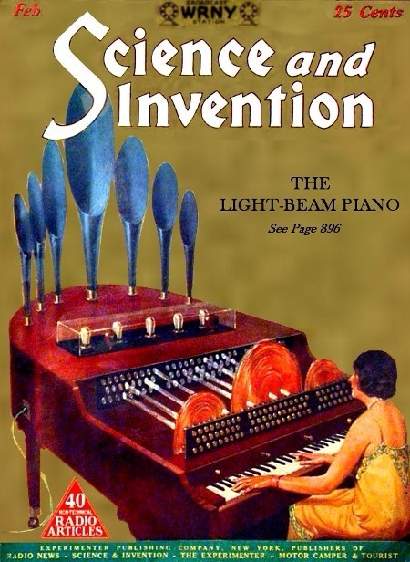

In essence, what this speculative design presents as desirable marks the antithesis of what we consider technological utopias now. It is enormous, heavy, stationary, indiscreet, hot, and wired. And making this comparison already brings our current techno-aspirations into sharper focus. How will today's Wired and Popular Science magazine covers appear 94 years from now? Will our current media devices have laid to rest the desires and fears they were engineered to satisfy or overcome? Or, if (inevitably) many of those desires and fears remain, what will have replaced our iPhones, Oculus Quests, and Spotify playlists in order to address them?

Like Media Archaeology, Design Fiction uses the familiar to help us imagine the unfamiliar. It often invents technologies which are almost familiar but not quite here yet, such as the oft-cited Human Computer Interface depicted in the film Minority Report, or which are so far into the future that we can only envision them through familiar equivalents, such as the Tricorders, Communicators, and Phasers of the original Star Trek series (Bleecker), which were drawn containing 1960's electronics components more often seen inside consumer television and hi-fi systems (Joseph). It communicates these imaginary technologies through well-established media genres such as product advertisements, retail catalogs, user manuals, travel guides, and technical diagrams. But critically, the most socially ambitious Design Fictions use the imagined future, rather than Media Archaeology's past, to make sense of the present. Projects such as Kristina Anderson's "Magic Machines" workshops suggest that innovation for its own sake is absurd and meaningless if we haven't figured out how to solve the problems we currently face with the abundant technologies we already have (Blythe, Andersen, Clarke, & Wright).

The Dataton System 3000

For our ongoing research into historically-informed sound synthesis, we took as a first object of study the Dataton System 3000. This modular synthesizer and audio mixer was designed by Björn Sandlund in Sweden during the 1970’s as a pedagogical tool. An official government report published in 1977 recommended that every music school in the country be provided with one (Elektronmusikutredningen). Unfortunately, a subsequent right wing administration eliminated these plans, and Sandlund's Dataton company instead moved into multimedia presentation technology (Sandlund). As such, the System 3000 represents a particular utopian vision of the future which was never reached. Historically, the specific modules available to us have been used for electronic composition courses by KMH, in the private studio of Swedish composer Leo Nilsson, and at the Sibelius Academy in Helsinki.

At our disposal was a working system with over one dozen modules, with which the workshop participants could familiarize themselves. This particular System 3000 contains modules for sound input and generation (Quad Input Amplifier 3001, Quad Sound Generator 3002, Noise Generator 3004); for sound processing (Quad Universal Filter 3103, Quad Envelope Shaper 3104, Ringmodulator 3105); for mixing, panning, and output (Master Mixer 3201, Sub Mixer 3202); and for transforming, regulating, and distributing power (Power Supply 3320). Several of these modules were duplicated in our collection. The Dataton's unique design feature is a clever system of horizontal and vertical busses routed through rugged, interlocking connectors on the four side panels of each module. This allows modules to be laid out like tiles and directly plugged together, with the main stereo bus and control voltages flowing from left to right, four discrete audio channels running from top to bottom, and the supply power available at any connection. Besides the in-built connectors, special patch cables can be used to span longer distances.

[IMAGE: Dataton System 3000 (by the authors)]

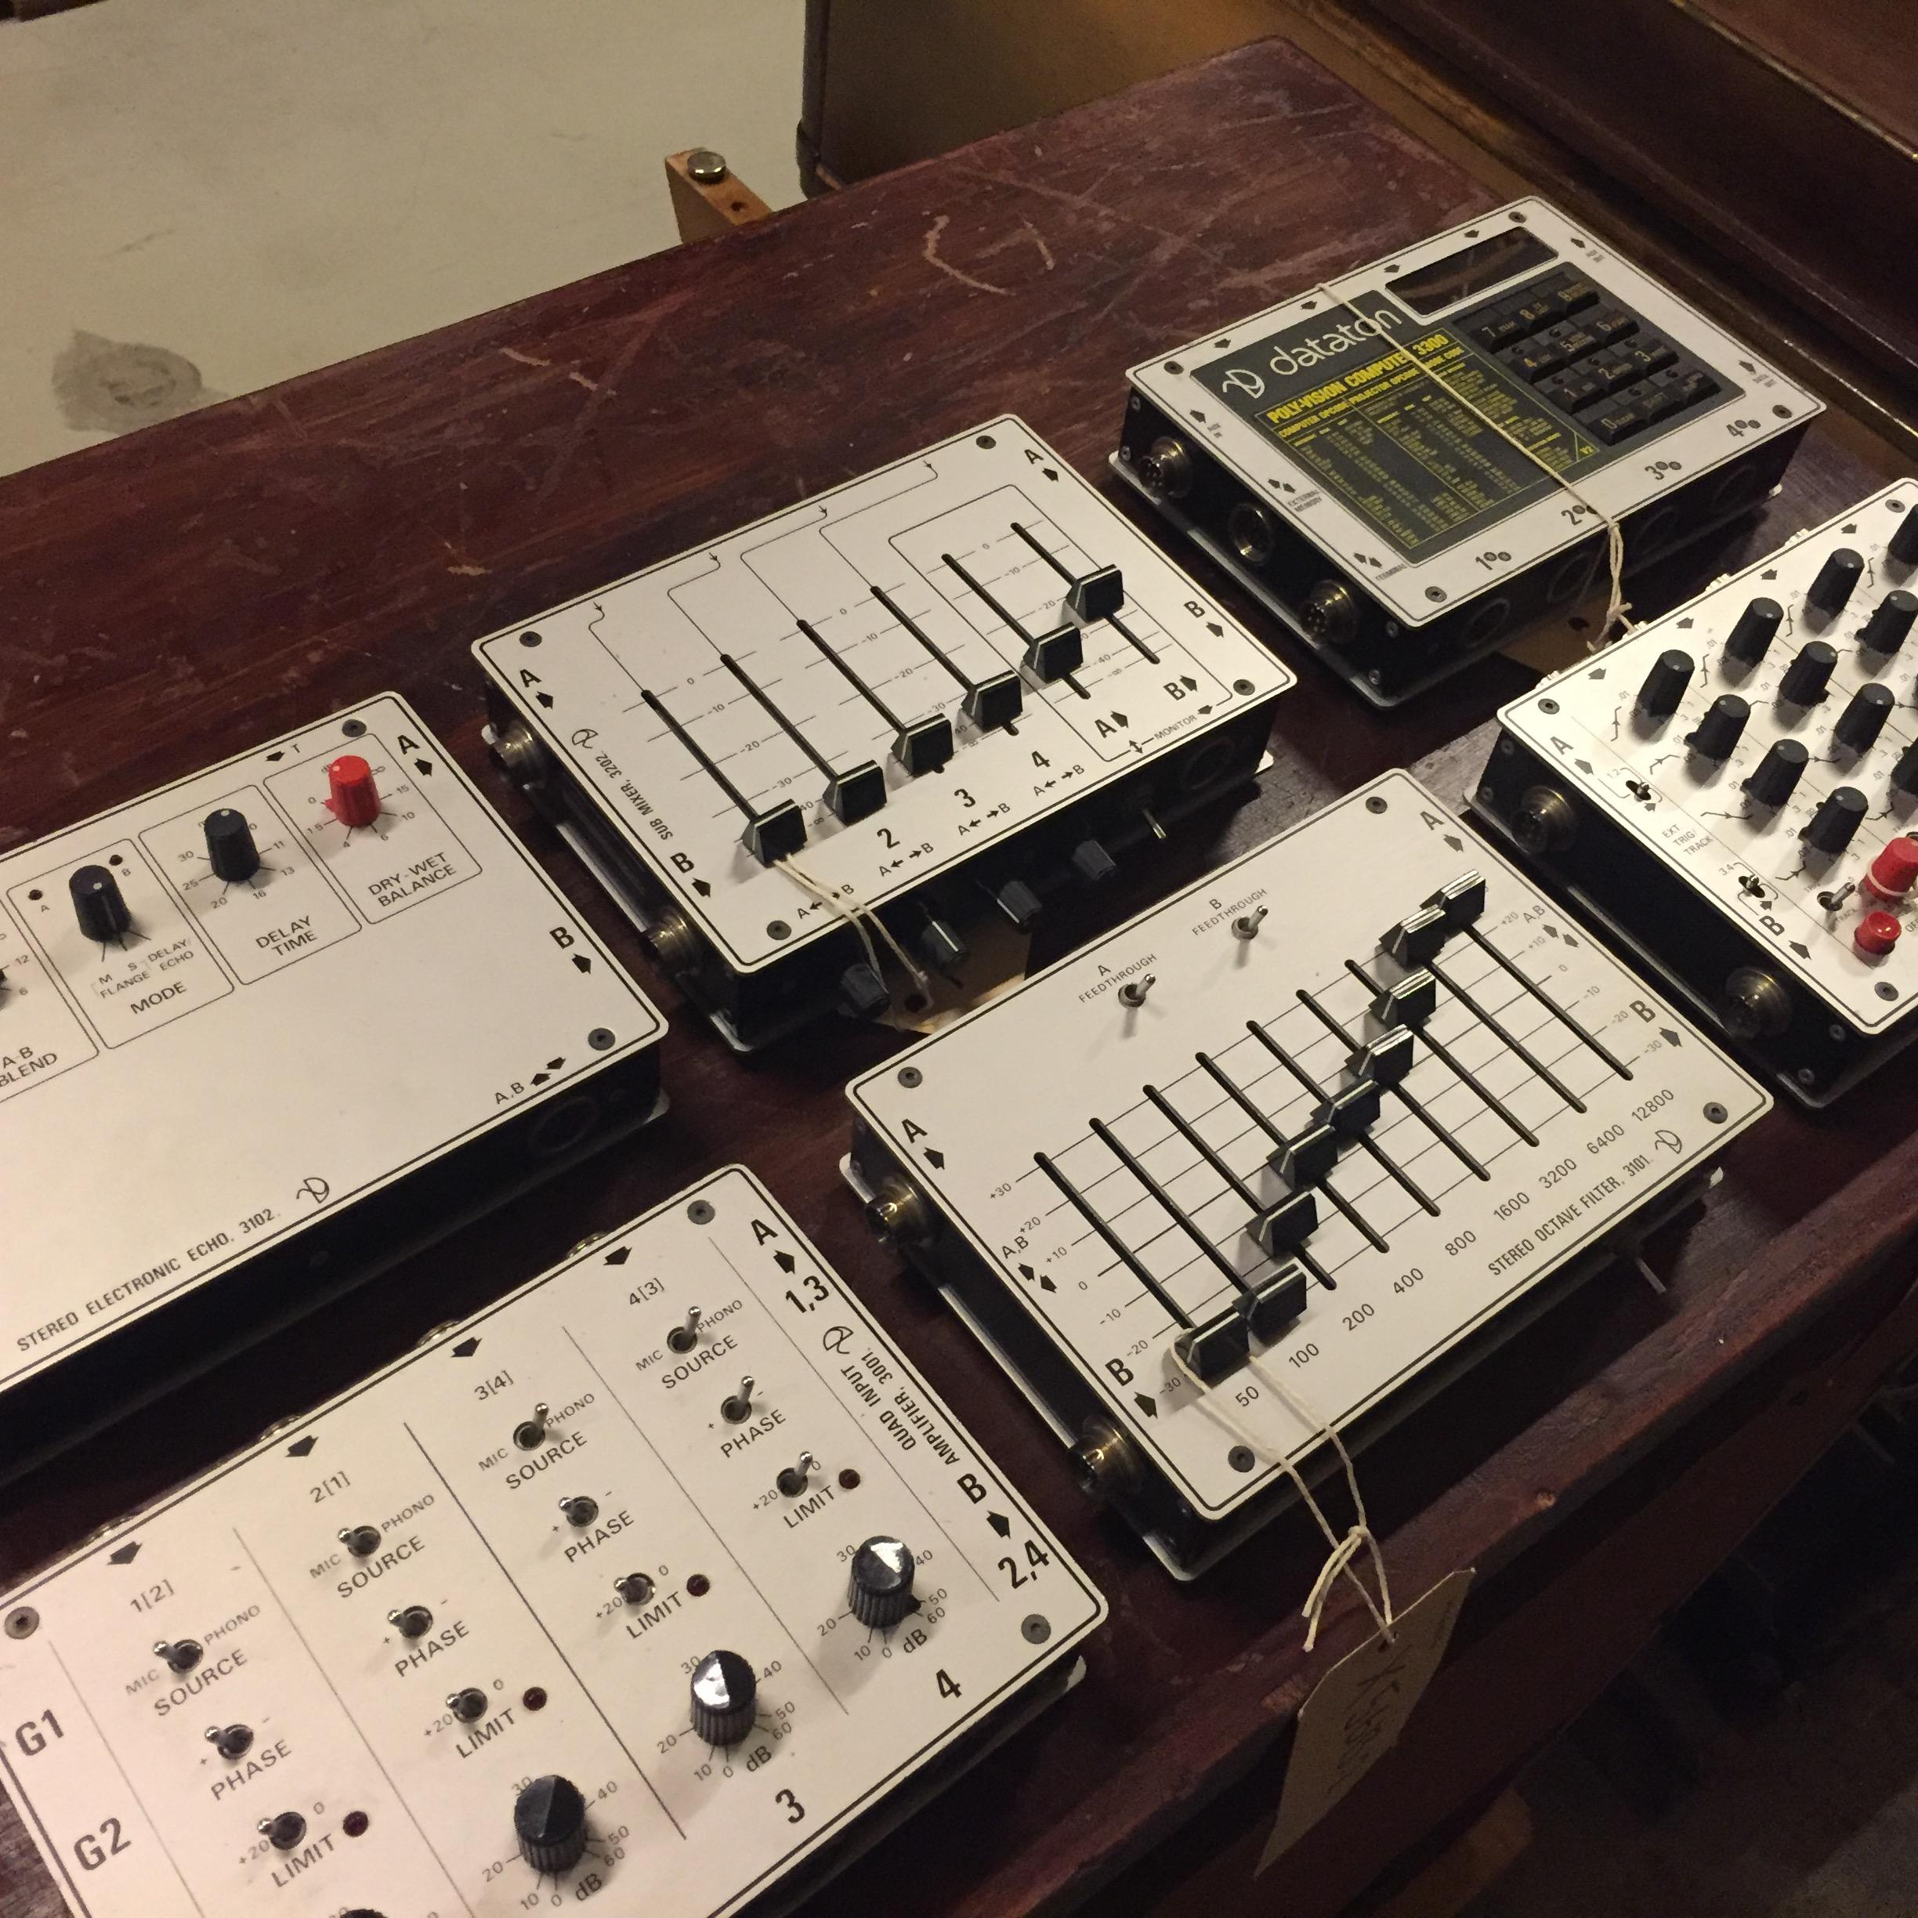

As with the early Buchla and Serge synthesizers, no keyboard controller was provided (although Sandlund did have eventual plans for both touch and breath controllers). The physical interface of the System 3000 - consisting entirely of knobs, faders, switches, and pushbuttons - presents many of the same possibilities and limitations in live performance as other modular instruments of the time, which the workshop participants responded to in various manners. While a digital sequencing module also exists (Polyphonic Computer 3301), it was considered too complicated for use within the timeframe of this particular workshop. The selected modules were documented through a series of YouTube videos for the participants' reference:

<https://youtube.com/playlist?list=PLAz5IzRCksDJf9ENkU_qYhac3TlgE09Df> [LINK REMOVED FOR ANONYMIZING PURPOSES]

3. METHODOLOGY

Workshop Aims

The workshop's aims were as follows:

1. To investigate the use of an under-researched historic sound synthesis technology, the Dataton System 3000, in a contemporary setting.

2. To use what was learned from direct experience with the Dataton System 3000 to inform and inspire speculative future sound synthesis technology.

3. To discuss what sort of socially constructed utopias exist in contemporary electronic music, as expressed by the participants through their speculative instrument designs, and how these contemporary utopias relate to those of the mid-1970's, as expressed by Björn Sandlund through the Dataton System 3000.

Participant Demographics

The workshop involved ten participants, who were mainly students describing themselves as composers, performers, audio engineers, sound designers, and music producers. All were in their 20's-30's. Despite efforts to involve more women in the workshop, only one participant was female. The majority of the participants mainly worked in software, relying on the computer keyboard, mouse, MIDI keyboard, and other MIDI devices as controllers, as their main sound production environment. The remaining 30% of them worked primarily with commercially manufactured, hardware-based musical instruments. Most reported feeling reasonably knowledgeable about the history of electronic music and the instruments used to create it. There was a balance between those who created sound in real time performance situations and those who worked largely in non-real time composing and editing situations. And about half the participants expressed prior knowledge of basic sound synthesis techniques (AM, FM, additive, subtractive, etc) and some experience with patchable, modular-type environments.

Workshop Methods

During the first phase of the workshop, participants were provided with a series of video tutorials, historical manuals, and other documentation explaining the basic functions of the Dataton System 3000. They were then invited to an introductory lecture which introduced the themes of the workshop and the practice of Media Archaeology. Following this, participants worked in small teams of two or three to create basic sound compositions demonstrating the capabilities of the Dataton system over a week’s time. The only guidance for these compositions was that, while they could use basic digital editing techniques, they should avoid extensive post-processing so that the original source material remained recognizable as such. These compositions were shared and collectively analyzed during the second session.

The second phase of the workshop began with an introduction to the practice of Design Fiction, along with numerous examples of speculative design projects in various media (television, film, print, etc). We also looked at users manuals and promotional literature of other historic and contemporary synthesizers as templates of how one might describe an electronic music instrument to its potential users. The task for each group during the subsequent week was to design a speculative sound instrument, based on their experiences with the System 3000, in the form of drawn or collaged images and short written descriptions. Again, few limitations were applied to the process, and technical feasibility in particular was excluded from consideration.

During the third and final workshop phase, the participants presented their designs in the form of a sales pitch supported by the images they created, and the features and themes of the designs were discussed and analyzed by the entire group.

Data Gathering and Analysis

Besides presenting a sound composition and speculative instrument design, participants were asked to fill out three surveys. The first covered their backgrounds and experiences, the second asked them to reflect on the process of using the Dataton System 3000, and the third asked them to describe specific aspects of their design proposals. The general workshop meetings were recorded and transcribed. Following the workshop sessions, the authors' task was to thematically analyze the discussions around both sets of outcomes - the sound compositions and the speculative instruments - assisted by the recordings and survey responses. We sought to determine where thematic aspects might converge or diverge, both internally between the outcomes of the different participant groups, and more generally between the outcomes of the workshop and the historical device under study.

4. OUTCOMES

Presentation of Compositions

The Media Archaeological explorations of the Dataton System 3000 during the first workshop week resulted in five compositions, which were presented at the second general meeting. Three of the compositions were created by individual participants, while two were created by groups of three. The first group piece was composed by editing together single takes of different patches which the group set up, passing the material from one participant to another in stages. The second group’s piece was more of a collective improvisation, with two participants interacting with different parts of the patch while the third handled mixing the results and conducting the actions of the other two. Many sounds used in the pieces arose from the ease of creating chaotic feedback patches between the voltage controlled oscillators of the system, while two compositions in particular employed vocal or piano sounds as control signals within the Dataton. Generally, each work involved the use of a fairly limited number of sonic "characters" based on specific patches, typically steady, singular rhythmic elements alongside "organic" or "noisy" sounds, drones, and "watery" sounds from the resonant voltage controlled filters.

Dataton Analysis

While aesthetic commentary on the compositions themselves was a part of the discussion, the focus of our meeting was an analysis of the participants' user experiences with the instrument. The consensus of the groups was that the Dataton was a fun and exciting tool with which to experiment and discover new sounds, but that the instrument was sometimes clumsy and often highly unpredictable. This term was used in both a negative and a positive context, however, indicating that "happy accidents" were in fact welcome and inspiring at times. Participants often reported that the controls were incredibly sensitive and could respond to the smallest adjustments with radical changes in the overall sound, but that they could not understand why certain sounds happened, particularly in more complex patches. One participant summarized the Dataton as both "intuitive but counterintuitive". Despite this apparent complexity, many also said that they found the architecture of the instrument limiting, and wished for more flexible routing methods. Several felt that they were being directed by the possibilities of the machine rather than the instrument expressing the user’s musical ideas, and noted that the omission of keyboard or sequencer in favor of more direct interaction with the various controls of the modules made the production of melodic, harmonic, or rhythmic progressions quite difficult. Noting that the purpose of the Dataton was pedagogical, many expressed a wish that the system's user interface were more self-explanatory, even though printed manuals had been provided alongside the instrument. And finally, participants speculated that the Dataton was intended as a radical departure from previous music making tools, and ideal for students and young people in that it was immediate, accessible, portable, and hands-on, but that it might not have been meant as an instrument for serious musical composition.

Presentation of Instrument Designs

At the end of the second week, the participants presented five speculative Design Fiction instruments. Each group responded to elements of the Dataton System 3000 which they found either inspiring or frustrating during the previous week, and combined those elements with existent or imaginary technologies in ways which illuminated their own utopian ideas for music instruments of the future. Negative influences included the Dataton's complexity, "clumsy" interface, and limited routing. Positive influences included its unique, tiled method of module connectivity, its accessible and pedagogic nature, and the immediacy and spontaneity of its physical controls. Contemporary points of reference included Korg's littleBits synthesizer, the Monogram Creative Console, and the ReacTable interface [CITATIONS]. Well-known children's toys such as Lego blocks and the Rubik's Cube also inspired their designs.

[FIGURES: selection of project designs]

1. BONK

BONK uses ubiquitous computing and augmented reality technologies combined with a single knob interface, which allows the user to play a programmable software synthesizer on any surface. Biometric sensors identify both the user and the finger they are using, allowing access to patches created by themselves and other users in the community as well as defined, finger-specific parameters. An Artificial Intelligence tutor guides new users through using the system, while bio-chip implants allow them to hear the sounds they create directly in their eardrums.

2. The Velvet Pancake

Users share this endlessly-reproducible "organic hybrid synth" by breaking off a piece from an already-existing instrument, embedding a special 10G chip in that piece, and then growing a new Velvet Pancake for themselves. The instrument is controlled by a central touchplate, buttons which provide access to specific field recording sounds captured via a global network of mobile phones, and direct mind control. While the instrument strives to express the player's sonic ideas as accurately as possible, the design also includes a switch to disable this "quantization" and allow random surprises to occur.

3. Sound Cubes

Sound Cubes represent a physical patching system of small blocks laid out in space and communicating wirelessly. Each cube has a specific, programmable function as either a sound generator, control signal, or audio output via a transducer speaker. The proximity of a control cube to a sound generator intensifies its effect, the facing direction of a control cube determines which sound generator it might affect, and feedback loops could be created through clever arrangement of generator and control cubes. The cubes themselves utilize very cheap technology, and can be 3D printed from household plastic waste.

4. Dataton Cube

This portable and self-contained design, based on a very popular toy from the 1980's, takes the form of a cube made up of smaller cubic modules. Each module has a small touchscreen, runs a configurable DSP algorithm, and has a signal routing based on the orientations of its four edges. Routing is changed by twisting the rows and columns of the cube until the modules line up in the desired order. Its scalable complexity makes it as equally suitable for children as for performing musicians.

5. Torn ("Tower")

Directly inspired by the form factor of the Dataton, this hexagonal tower of analog synthesizer modules strives to encourage a collaborative approach to music making. Players on each side of the tower pass the ends of patch cables to other players, who may not know what sort of signal or audio might be sent to them. This unpredictability lends game-like qualities to social interaction.

5. DISCUSSION

A thematic graph of the various technologies and affordances proposed by these speculative instruments might look like this:

[FIGURE: instrument themes]

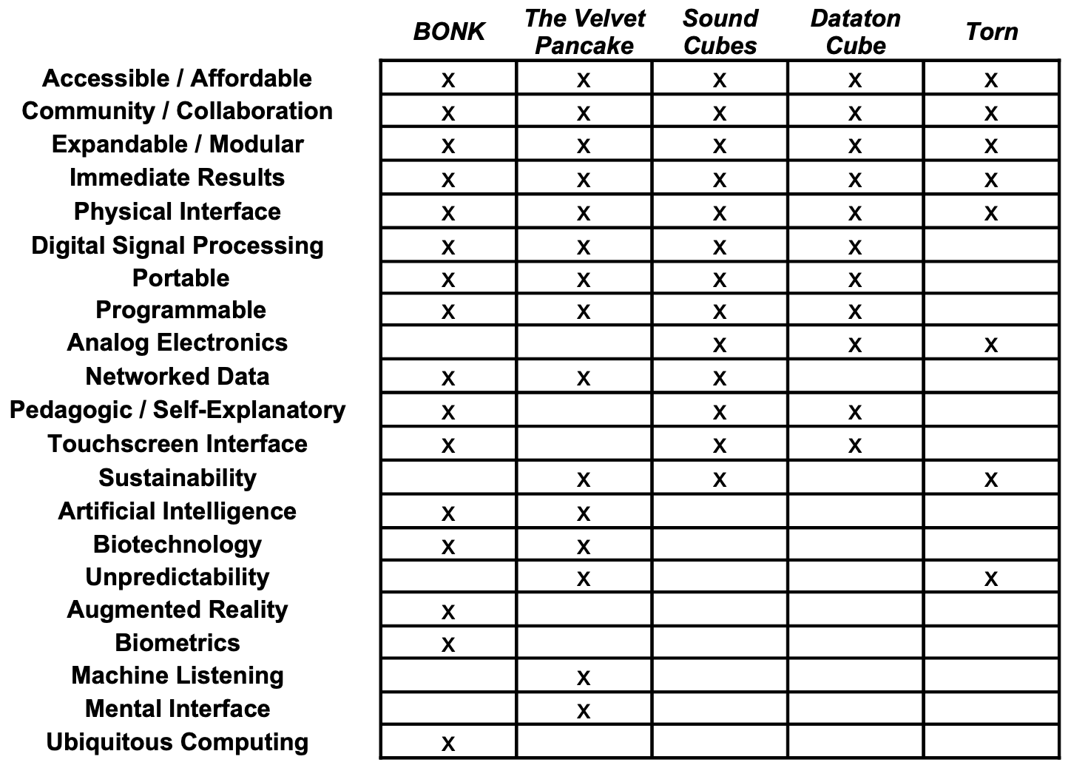

Overwhelmingly, the participants envisioned instruments which were portable, immediately ready to produce sound, scalable and extensible in their level of complexity to accommodate both beginners and more advanced users, and provided analog-style physical control over programmable DSP. Furthermore, they envisioned systems whereby both these instruments and their users could be connected to each other through some sort of networking. The influence of contemporary User Experience (UX) design strategies is clearly evident in the rejection of written documentation over "intuitive" and self-explanatory interfaces. Quite curiously, while a few projects mentioned the emulation of analog waveforms or the use of field recordings, none of the participants would venture to describe how their instrument actually sounded. Instead, they universally emphasized that the instruments could sound like almost anything, and that the users should have unlimited freedom in deciding how exactly. And visually, the rectangular, interconnecting, modular form factor of the Dataton was clearly reinterpreted in imaginative ways.

While not inherently contradictory, some of these design goals present formidable challenges to realization which are familiar to designers of electronic music instruments both in the 1970's and today. How can an instrument allow anyone to make music the instant they pick it up (implying a very rigid set of default conditions strongly resembling the demos and presets found in commercially manufactured keyboard instruments, or the highly limited control parameters of early bass and drum sequencers), yet also provide limitless possibilities and an absence of constraints (implying a blank canvas approach found in softwares such as Pure Data, Supercollider, and Max, or the patch-programmable functionality of the Serge or Buchla modulars)? We find the affordances of the Dataton somewhere in the middle of these concerns. It is immediate and responsive, scalable and flexible, highly portable, and it was intended to be accessible by any Swedish music student. But it is also limited by its own architecture, unpredictable, overly-complex, and perhaps even un-musical. Yet clearly, many of its aims regarding the future of sound then remain a part of our utopian ideals now.

While it is quite entertaining to suggest an instrument based on telepathic mind control at an international academic conference, the utopia expressed by that particular affordance is a recurring theme in the history of electronic music instruments. Daphne Oram, for example, designed her Oramics system out of a keen desire to express the sounds she heard in her head as clearly as possible, without translation through the limitations of either a symbolic language or other performers [Oram]. Likewise, the idea that anyone could grow a synthesizer, play one on the wall, or dump one out of a bag onto the floor like a pile of Lego bricks, all spring from the same vision of unmediated accessibility which Laurie Spiegel feels could be realized in electronic music:

"Technology is a tremendous liberator. It blows up power structures. Women were naturally drawn to electronic music. You didn't have to be accepted by any of the male-dominated resources. You could make something with electronics, and you can present music directly to your audience. And that gives you tremendous freedom." [Spiegel, Sisters With Transistors]

Utopias are not defined by their technologies, but by their ethics. Flying cars and clairvoyant detectives exist in imaginary utopias not for their own sake, but in the hopes that they improve the general quality of life. This corresponds with what Tresch and Dolan refer to within their organology of ethics as the aims to which an instrument is used [Tresch & Dolan]. The ethical positions discussed in this workshop harmonize well with those espoused by the NIME community [Morreale et al]. Participants were largely concerned with instruments which made sound creation easily accessible to many different types of users, were ecologically sustainable, promoted community involvement and shared resources, addressed the social isolation of what one participant labelled the "lonely synthesists" (particularly in the current pandemic situation), and protected data privacy even while trending-yet-problematic technologies such as biometrics, machine listening, Artificial Intelligence, Augmented Reality, and data clouds were involved. [SOMETHING MORE HERE?]

6. CONCLUSION

In this paper, we have presented the beginnings of a methodology for the design of new sound instruments based on the ethics and affordances of the imaginary, rather than the dictates of the plausible. This approach is informed by examples from the history of electronic music in Sweden. To test and expand this methodology, we plan future workshops involving different instruments and participant groups. We use the term 'reenactment' rather than 'reconstruction' to indicate a focus on the affordances of the devices and the aims to which they were used, rather than on their specific technical implementations. Since many of the historical devices under study remain as rare or unique specimens archived under museum conditions, the possibilities of reverse-engineering and reenactment must be considered. Two instruments from the studio of composer Ralph Lundsten stand out as promising: the Andromatic polyphonic synthesizer created by Erkki Kurenniemi in 1968, and the handheld Ljuddar sound generators used by Lundsten and Nilsson in workshops with children and students throughout Sweden in the 1960's, which many Swedes of that generation recall as their first experience with electronic sound.

We recognize that, while our initial survey was stimulating, it was also limited in its scope and reflected the imaginations of only a very specific demographic. Therefore, we anticipate that diversifying our participant base, particularly in terms of age and gender, will result in even more insightful results. As the taxonomy of sound instruments continues to take essential steps away from a focus on the technical means of causation, it acknowledges both ethics and affordances as meaningful designations. We hope that a comparative analysis of the imagined possibilities of each, explored in both past and future scenarios through practices such as Media Archaeology and Design Fiction, can find a more prominent role in the development of new interfaces for music production. Certainly, such a speculative analysis continues to form a substantial basis for our own research into historically-informed sound synthesis.

7. ACKNOWLEDGEMENTS

With thanks to Björn Sandlund, Daniel Araya, Sandra Pauletto, and the workshop participants Erik, Giovanni, Jacob, Joel, Johannes, Linus, Marcel, Ola, Todd, and Tove.

8. COMPLIANCE WITH ETHICAL STANDARDS

This research took place through a collaboration between KTH Royal Institute of Technology, KMH Royal College of Music, the Swedish Performing Arts Agency/Statens Musikverket, and EMS Elektronmusikstudion, with support from the Swedish Research Council/Vetenskapsrådet. All workshop participants were informed and consent was obtained regarding the nature of the research, the activities involved, the data collected, and their rights regarding the use of that data. All general meetings of the workshop were held as video conferences to reduce the risk of COVID-19 transmission during the global pandemic.

9. CITATIONS (I will format these correctly when cleaning up the document)

Andersen, Kristina. Making Magic Machines. Doctoral thesis. KTH, School of Computer Science and Communication, Media Technology and Interaction Design, 2017.

Andersen, K. and Gibson, D. (2017). The instrument as the source of new in new music. Design Issues, 33(3), 37-55. https://doi.org/10.1162/DESI_a_00450

Armitage, Jack and Andrew McPherson. Crafting Digital Musical Instruments: An Exploratory Workshop Study. NIME’18, June 3-6, 2018, Blacksburg, Virginia, USA.

Birnbaum, D., Fiebrink, R., Malloch, J., & Wanderley, M. (2005). Towards a dimension space for musical artifacts. Proceedings of NIME 2005. Vancouver: University of British Columbia.

Bleecker, Julian. Design Fiction: A short essay on design, science, fact and fiction. NearFuture Laboratory. March 2009.

Blythe, M., H.K.G. Andersen, R. Clarke, P. Wright. "Anti-solutionist strategies : seriously silly design fiction." Proceedings of the 2016 CHI Conference on Human Factors in Computing Systems - CHI '16, New York. Association for Computing Machinery, Inc, 2016: 4968-4978.

Bussigel, Peter, Stephan Moore, Scott Smallwood. Reanimating the Readymade. NIME’19, June 3-6, 2019, Federal University of Rio Grande do Sul, Porto Alegre, Brazil.

Elektronmusikutredningen. Elektronmusik i Sverige. Statens offentliga utredningar, 0375-250X ; 1977:30. LiberFörlag/Allmänna förl. 1977. https://lagen.nu/sou/1977:30

Hertz, Garnet and Jussi Parikka. "Zombie Media: Circuit Bending Media Archaeology into an Art Method." Leonardo, vol. 45 no. 5, 2012, p. 424-430. Project MUSE muse.jhu.edu/article/484774.

Jordà, Sergi. (2004) Instruments and Players: Some Thoughts on Digital Lutherie, Journal of New Music Research, 33:3, 321-341, DOI: 10.1080/0929821042000317886

Jordà, Sergi. Günter Geiger, Martin Kaltenbrunner and Marcos Alonso. ReacTable. 2005. https://reactable.com/

Joseph, Franz. Star Trek Star Fleet Technical Manual. Ballantine Books, 1975.

Lepri, Giacomo and Andrew McPherson. Fictional Instruments, Real Values: Discovering Musical Backgrounds with Non-Functional Prototypes. NIME’19, June 3-6, 2019, Federal University of Rio Grande do Sul, Porto Alegre, Brazil.

Lepri G. and A. McPherson. Making up instruments: Design fiction for value discovery in communities of musical practice. In Proc. DIS, 2019.

Lepri, G. and A. McPherson. Mirroring the past, from typewriting to interactive art: an approach to the re-design of a vintage technology. In Proc. NIME, 2018.

Lindley, J. and P. Coulton. Back to the future: 10 years of design fiction. In Proc. British HCI, pages 210–211, 2015.

Magnusson, Thor. Contextualizing Musical Organics: An Ad-hoc Organological Classification Approach. NIME'17, MNay 15-19, 2017, Aalborg University Copenhagen, Denmark.

Magnusson, Thor. (2017) Musical Organics: A Heterarchical Approach to Digital Organology, Journal of New Music Research, 46:3, 286-303, DOI: 10.1080/09298215.2017.1353636

Monogram. Monogram Creative Console. 2019. https://monogramcc.com/how-it-works/

Morreale, Fabio, Nicolas Gold, Cécile Chevalier, and Raul Masu. NIME Principles & Code of Practice on Ethical Research. 18 November 2020. https://www.nime.org/ethics/

Moriwaki, Katherine and Jonah Brucker-Cohen. MIDI Scrapyard Challenge Workshops. Nime’07, June 7-9, 2007, New York, NY, USA.

Ojanen, Mikko, Jari Suominen, Titti Kallio, Kai Lassfolk. Design Principles and User Interfaces of Erkki Kurenniemi’s Electronic Musical Instruments of the 1960’s and 1970’s. NIME07, June 6-10, 2007, New York, USA.

Ojanen, Mikko. User Stories of Erkki Kurenniemi’s Electronic Musical Instruments, 1961–1978. Doctoral thesis. Faculty of Arts of the University of Helsinki. 2020.

Oram, Daphne. An individual note: of music, sound and electronics. London : Galliard Ltd ; New York : Galaxy Music Corporation, 1972.

Paine, Dr. Garth. Towards a Taxonomy of Realtime Interfaces for Electronic Music Performance. Proceedings of the 2010 Conference on New Interfaces for Musical Expression (NIME 2010), Sydney, Australia.

Parikka, Jussi. What is Media Archaeology? Polity Press. 2012.

Richards, Tom. Oramics: Precedents, Technology and Influence: Daphne Oram (1925- 2003). Doctoral thesis, Goldsmiths, University of London. 2018.

Reid, Gordon. "Korg littleBits Analogue Synthesizer Kit". Sound On Sound Magazine, April 2014. https://www.soundonsound.com/reviews/korg-littlebits

Spiegel, Laurie. IN: Sisters with Transistors. Directed by Lisa Rovner. Anna Lena Films, 2020.

Sandlund, Björn. The Early Synth Days. Panoramicum Förlag. 2019.

Savery, Richard, Benjamin Genchel, Jason Smith, Anthony Caulkins, Molly Jones, Anna Savery. Learning from History:

Recreating and Repurposing Sister Harriet Padberg’s Computer Composed Canon and Free Fugue. NIME’19, June 3-6, 2019, Federal University of Rio Grande do Sul, Porto Alegre, Brazil.

Science and Invention. Vol XIII, Whole No. 154, No 10, February 1926. Archived at: https://worldradiohistory.com/Archive-Electrical-Experimenter/SI-1926-02.pdf

Teboul, Ezra Jérémie. A Method for the Analysis of Handmade Electronic Music as the Basis of New Works. Doctoral thesis, Rensselaer Polytechnic Institute. 2020.

Tomás, Enrique, Thomas Gorbach, Hilda Tellioglu, and Martin Kaltenbrunner. Material embodiments of electroacoustic music: An experimental workshop study. NIME’19, June 3-6, 2019, Federal University of Rio Grande do Sul, Porto Alegre, Brazil.

Trappe, Christoph. Making Sound Synthesis Accessible to Children. NIME’12, May 21 – 23, 2012, University of Michigan, Ann Arbor.

Tresch, John and Emily I. Dolan. Toward a New Organology: Instruments of Music and Science. Osiris, Vol. 28, No. 1, Music, Sound, and the Laboratory from 1750–1980 (January 2013), pp. 278-298. The University of Chicago Press on behalf of The History of Science Society.

Xambó, Anna, Sigurd Saue, Alexander Refsum Jensenius, Robin Støckert, and Øyvind Brandtsegg. NIME Prototyping in Teams: A Participatory Approach to Teaching Physical Computing. NIME’19, June 3-6, 2019, Federal University of Rio Grande do Sul, Porto Alegre, Brazil.